CLIMATE CHANGE AGREEMENTS: Buy-Out Fee Overpayment

«${currentDate?date?string('dd MMMM yyyy'»

Operator: «${account.name}»
Company registration number: «${(account.companyRegistrationNumber)!}»
Address for service: «${account.location}»

CCA Buy-Out Fee Overpayment
Dear «${account.primaryContact}»
We have determined that the target unit (identified in the CCA register as «${account.targetUnitIdentifier}») operated by «${account.name}» (you) may have overpaid the buy-out fee, following the submission of the secondary CCA performance report on «${(params.submissionDate.format('dd MMMM».
This has been calculated as follows:

Total buy-out fee required (£) – based on your recent Performance report | «${(params.buyOut.buyOutSurplusContainer.»
Previous buy-out fee received (£) | «${(params.buyOut.buyOutSurplusContainer.»
Secondary surplus gained - based on your recent Performance report | «${(params.buyOut.buyOutSurplusContainer.»
Buy-out fee overpayment (£) | «${(params.buyOut.buyOutSurplusContainer.»

In order to claim the buy-out fee overpayment stated above, please send a completed ‘Buyout Overpayment Claim Form’ (blank copy attached) to ccapayments@environment-agency.gov.uk
If you have any further queries, please contact us in the first instance by sending an email to:
cca-help@environment−agency.gov.uk
Alternatively, you can call us on the following telephone number:
(03708) 506 506

Yours sincerely,
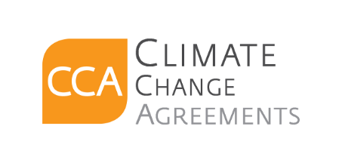
Climate Change Agreements Team

